**3-2 Assignment: Android Studio Introduction**

Christine R. Emerson

Department of Computer Science, Southern New Hampshire University

CS

-

360 Mobile Architect & Programming

Dr.

DiMarzio

September

11

, 2023

**Project Name:**

Christine_Emerson_Mod_3_Android_Studio_Intro

**Name the Button’s Text as "Say Hello" and Label ID of it as “ButtonSayHello”:**

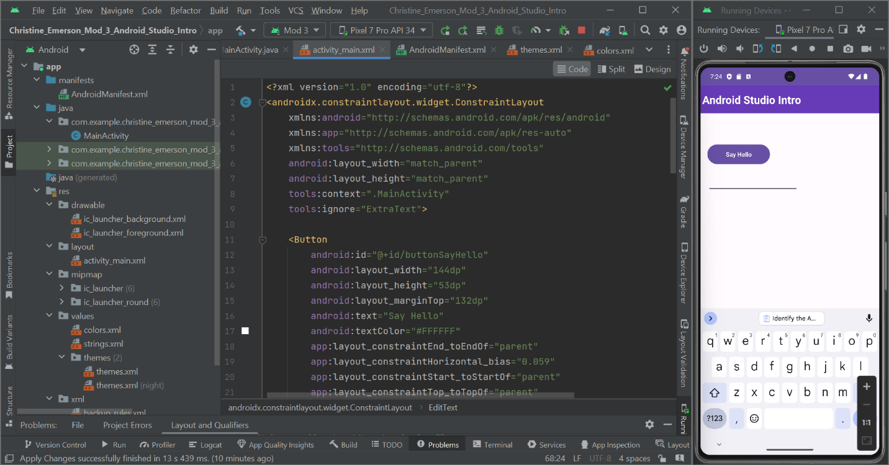

**Created a TextView, Remove all text, and Label the ID of it “textGreeting”:**

**Created a Toolbar, Created a TextView for it, and Changed the Text to “Android Studio Intro” into a TextView:**

**Created Plain Text (EditText) and Labeled the ID of it “nameText”:**

**Challenges Experienced with Android Studio**

I didn't face any significant challenges while working on my assignment in Android Studio. Initially, there was some vagueness in the instructions, but my professor clarified them, and after that, I had a smooth experience with no further issues.The initial vagueness in the instructions made it necessary for me to do some extra research and exploration to fully understand and implement the required tasks. However, once my professor provided clarification, I was able to proceed smoothly. I also found helpful resources online, including tutorials and forums, which provided additional guidance.

Regarding the user interface design, I didn't encounter any challenges during the assignment. Android Studio offers a wide range of layout options and design tools, and I found it relatively straightforward to select the most appropriate ones for my project. Additionally, ensuring that the UI elements had proper spacing and alignment for different screen sizes didn't pose any difficulties for me.

Overall, with the initial issue in the instructions resolved by my professor, my experience with Android Studio for the assignment was smooth, including the user interface design, where I didn't face any specific challenges. I'm looking forward to building on this experience and improving my Android development skills in the course.